
DISTRICT GIS PARAKH
Enhancement User Manual
Indore Inspection Forms (District GIS Parakh)

Step-by-Step, Screen-by-Screen Walkthrough by User Role, with Work Completed Status
(Prepared by MPSeDC GIS Department)
Version 2.0 — Phase 1 (Collectorate) & Phase 2 (Divisional Hierarchy)
Indore Collectorate & Indore Division | District GIS Parakh (MPSSDI)



Madhya Pradesh State Electronics Development Center (MPS@DC) State IT Center, 47-A, Arera Hills, Bhopal, M.P. 462011,
Phone: +91-755-2518300, Fax: +91-755-2579824
URL:www.mpsedc.mp.gov.in

Contents
About This Manual 3
Access URLs 3
Roles at a Glance 3
Phase 1 — Indore Collectorate Workflow 4
Part A — System Access & State Admin Setup 4
Step 1. Open the Application 4
Step 2. Department Login 4
Step 3. State Admin Dashboard 5
Step 4. Check the User List Before Creating a New User 5
Step 5. Add User — Create a Reporting Officer (Department HOD) 6
Step 6. Verify the Reporting Officer in the User List 7
Part B — Reporting Officer (Department HOD): Department Setup 8
Step 7. Reporting Officer Login 8
Step 8. Create an Inspector / Surveyor 8
Step 9. Preview the Department Inspection Form 9
Step 10. Verify the Inspector/Surveyor Record 10
Part C — Reviewing Inspections & Taking Action 12
Step 11. Open the General Form Report 12
Step 12. Review Submitted Inspections 12
Step 13. Verify or Reject the Inspection 13
Step 14. Department-Wide Status Rolls Up to State Admin 14
Part D — Nodal Officer: Collectorate-Level Monitoring 15
Step 15. Create the Nodal Officer (Collector's Representative) 15
Step 16. Nodal Officer Monitoring View 15
Phase 2 — Divisional Hierarchy 15
Step 17. Divisional Officer Login 16
Step 18. Division-Wide Launched Forms & Department Visibility 16
Step 19. Create Users at Division Scope 17
Step 20. Division-Wide User List 18
Step 21. Asset List & Asset Assignment 19
Step 22. Division-Level Department General Report 19
What's Next — Step 20: Mobile-Based Inspection 21
Step 23. Move Inspection Capture to the Mobile App 21
Work Completed — Consolidated Summary 22

About This Manual
This manual documents the Indore Inspection Forms module inside District GIS Parakh end to end, as walked through on the UAT and development environments. It is organised sequentially, screen by screen, in two parts:
- Phase 1 — Indore Collectorate workflow: State Admin setup, Reporting Officer (Department HOD) and Inspector creation, inspection review and action-taking (Steps 1–13).
- Phase 2 — Divisional hierarchy: Divisional Officer login, division-wide launched-form and user visibility across all eight districts of Indore Division, user creation at division scope, asset assignment, and division-level reporting (Steps 14–19), plus the planned move to mobile-based inspection (Step 20).
Each step states the Role Assigned (who performs it), the Activity Performed (what they do on that screen), and a Work Completed line recording whether that capability is confirmed working, still in progress, or a gap observed during the walkthrough — so this manual doubles as a live status record, not only an instructional guide.

Access URLs
- UAT (Phase 1 & Phase 2 testing): https://gisuat.mp.gov.in/parakhweb/
- PROD: https://geoportal.mp.gov.in/parakhweb/
- Development environment (used for Phase 2 divisional-hierarchy testing): 172.18.200.177/parakhweb/

Roles at a Glance
Six roles participate across the two phases. Each is created by the role above it in the hierarchy:
Role | Created By | Primary Activities
Divisional Officer (Commissioner-level) | Pre-provisioned (system level) | Phase 2. Division-wide visibility across every district and department under Indore Division; creates division- and district-scoped users; views the Department General Report across the division.
State Admin (Indore Collectorate Admin) | Pre-provisioned (system level) | Phase 1. Creates Nodal Officers and Reporting Officers (Department HODs); views registered-user counts and inspection statistics; reviews the General Form Report across all departments in the district.
Nodal Officer | State Admin | Phase 1. Acts as the Collector's monitoring representative; views the General Form Report read-only, across all departments, for district-level oversight.
Reporting Officer (RO) / Department HOD (incl. Limited Access variant) | State Admin or Divisional Officer | Owns one Department & Sub-Department (or, at division scope, one or more districts); creates Inspectors/Surveyors; reviews submitted inspections and Verifies or Rejects each one with remarks.
Inspector / Surveyor | Reporting Officer | Conducts the field inspection and submits the department-specific checklist against an asset/institution.

Phase 1 — Indore Collectorate Workflow
Full screen-by-screen detail for Steps 1–13 was covered in the Phase 1 manual; this section recaps each step with its confirmed Work Completed status.

Part A — System Access & State Admin Setup

Step 1. Open the Application
ROLE ASSIGNED: Anyone with issued credentials
ACTIVITY PERFORMED:
- Open the UAT or PROD URL and choose the Department login tile.
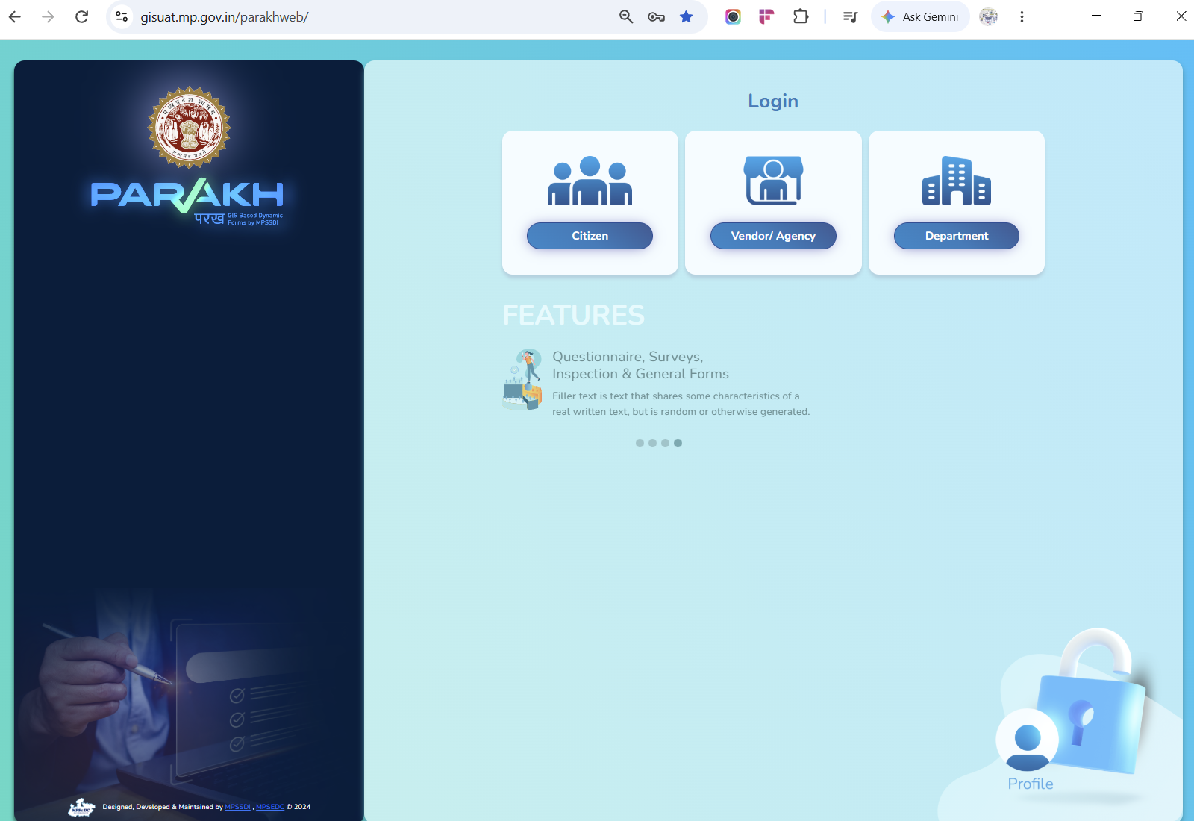
Screen 1 — District GIS Parakh landing page
WORK COMPLETED — COMPLETED: Landing page and Department login tile are live on both UAT and PROD.

Step 2. Department Login
ROLE ASSIGNED: State Admin (Indore Collectorate Admin)
ACTIVITY PERFORMED:
- Enter the department-level username and password in the Department Login pop-up and click Login.
- Example credentials used in this walkthrough — Username: indorecollectorateadmin, Password: Test@123.
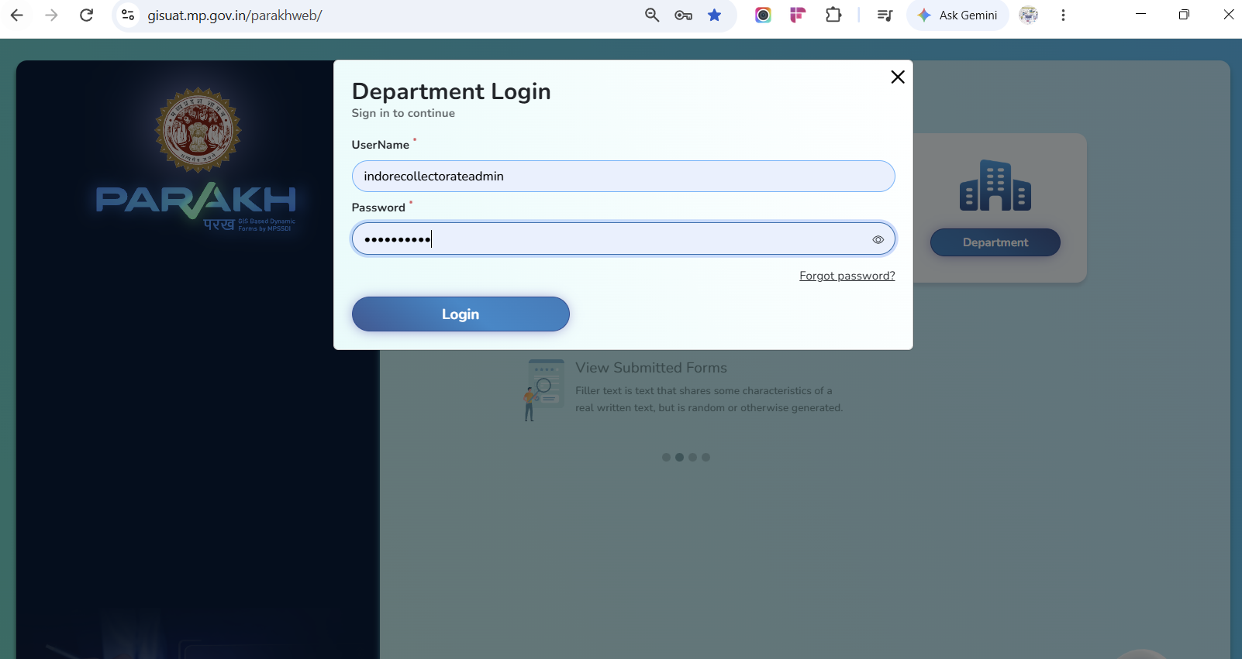
Screen 2 — Department Login pop-up
WORK COMPLETED — COMPLETED: Login confirmed working for State Admin credentials.

Step 3. State Admin Dashboard
ROLE ASSIGNED: State Admin
ACTIVITY PERFORMED:
- Lands on the Indore Collectorate dashboard showing registered-user counts by role and inspection statistics panels.
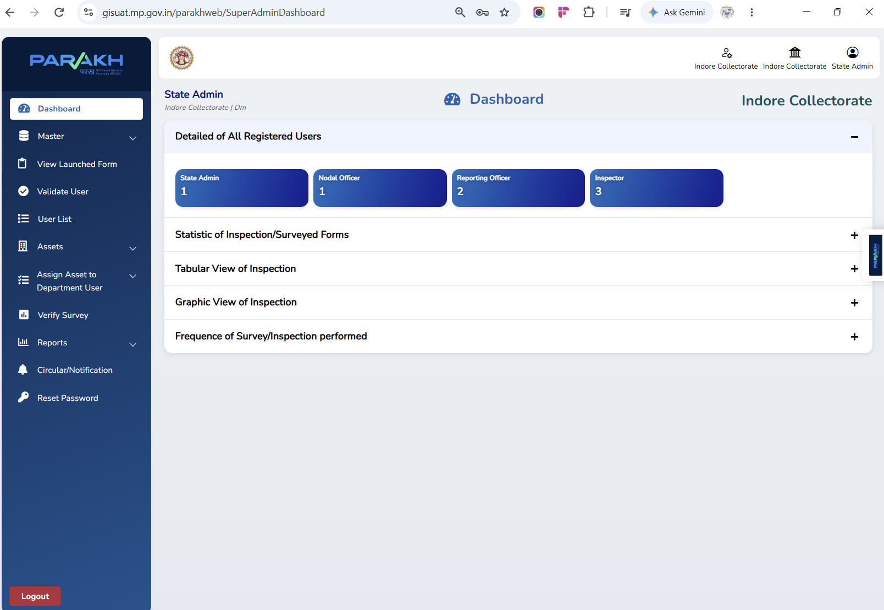
Screen 3 — State Admin dashboard
WORK COMPLETED — COMPLETED: Dashboard renders live counts (State Admin, Nodal Officer, Reporting Officer, Inspector) and statistics panels.

Step 4. Check the User List Before Creating a New User
ROLE ASSIGNED: State Admin
ACTIVITY PERFORMED:
- Master → User List, filtered by Department Name and User Type/Role, to check for an existing Reporting Officer.
- Before creating a new Reporting Officer, the State Admin checks Master → User List, filtering by Department Name and User Type/Role, to confirm whether the department already has a Reporting Officer mapped.
- The screen below shows two Reporting Officers already registered — one for the Farmer Welfare and Agricultural Development Department (Sub-Department: Directorate Farmer Welfare and Agriculture Development) and one for the School Education Department.
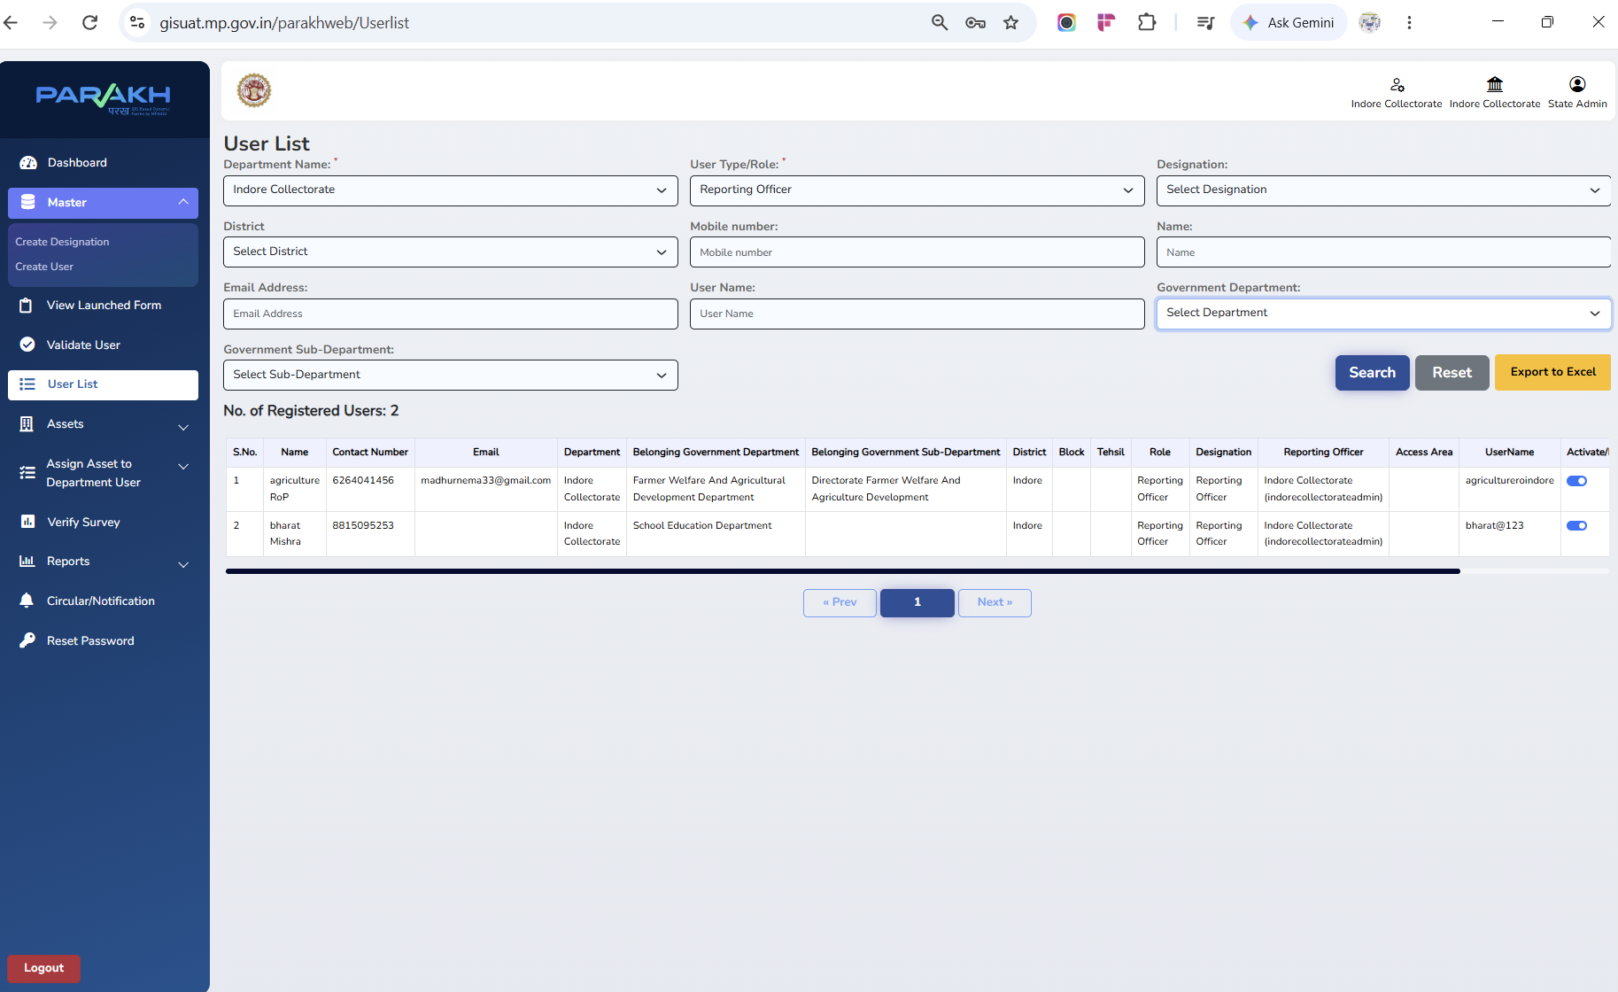
Screen 4 — User List filtered to Reporting Officers
WORK COMPLETED — COMPLETED: Filter and search confirmed working; existing ROs correctly listed.

Step 5. Add User — Create a Reporting Officer (Department HOD)
ROLE ASSIGNED: RO
ACTIVITY PERFORMED:
- Master → Create User; set Role = Reporting Officer; map Department & Sub-Department, District/Tehsil/Block; submit.
- Navigate to Master → Create User and complete the Add User form.
- Set User Type/Role to Reporting Officer and Designation to Reporting Officer.
- Select the Belongs to a Government Department and Belongs to a Government Sub-Department drop-downs to map this RO to the correct department (e.g. Higher Education Department → Rastriya Vidhi Sansthan, as shown).
- Fill District, Tehsil, Block and Urban/Rural to define the RO's jurisdiction, then click Add User.
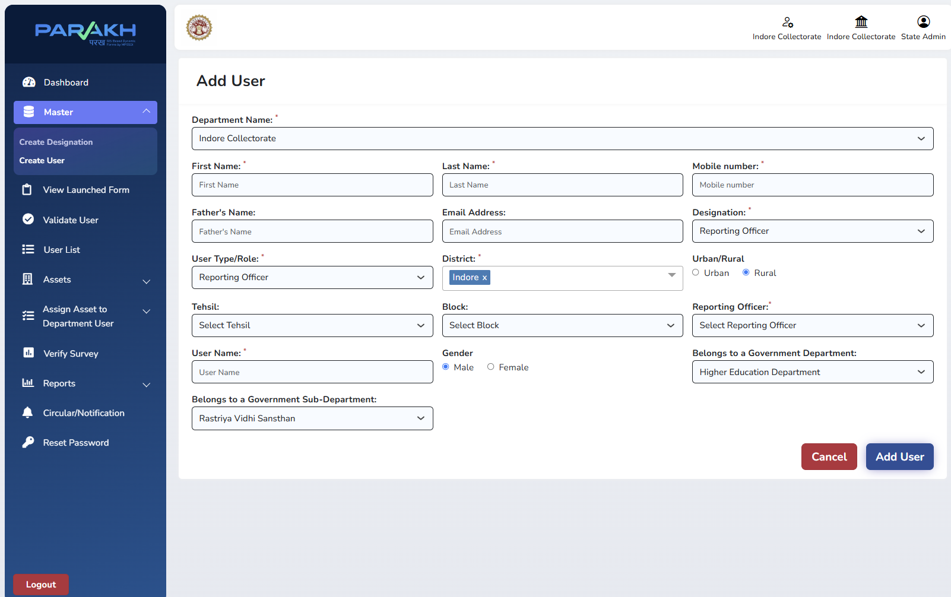
Screen 5 — Add User: Reporting Officer mapped to Department & Sub-Department
WORK COMPLETED — COMPLETED: Reporting Officer creation and department mapping confirmed working.

Step 6. Verify the Reporting Officer in the User List
ROLE ASSIGNED: State Admin
ACTIVITY PERFORMED:
- Return to Master → User List and search/filter to confirm the newly created Reporting Officer appears with the correct Department, Sub-Department, District and Designation.
- The list can be exported to Excel for offline record-keeping using the Export to Excel button.
- Search/export User List to confirm the new RO record.
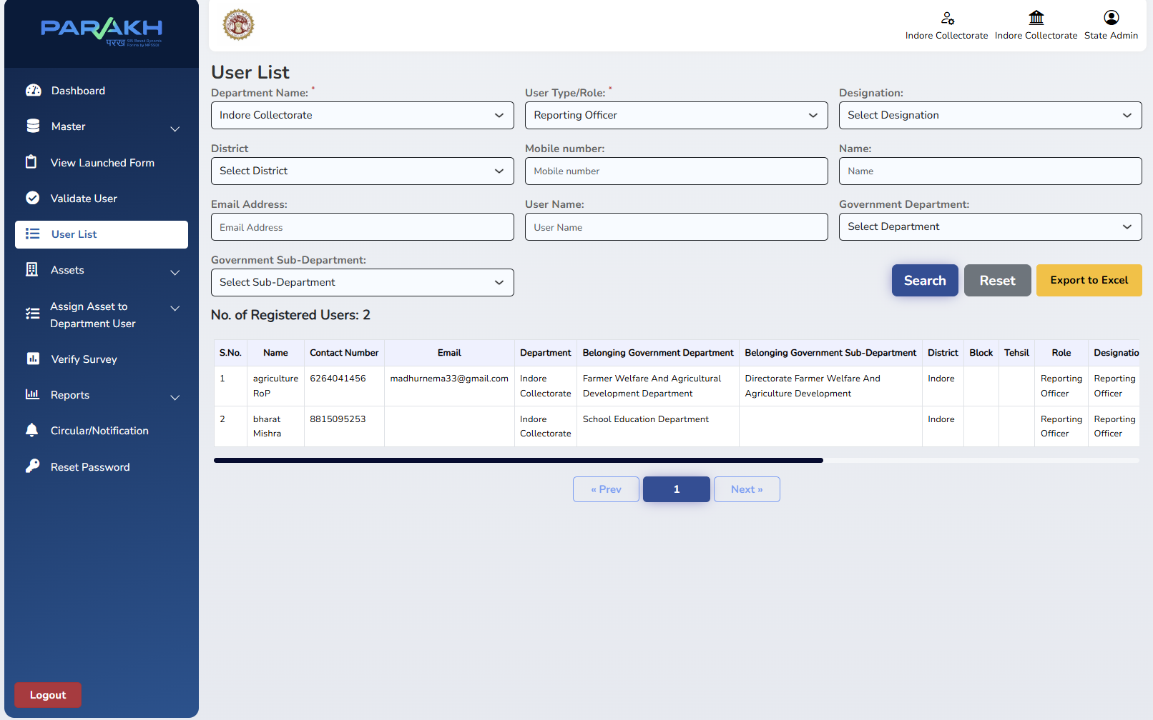
Screen 6 — User List confirming the Reporting Officer record
WORK COMPLETED — COMPLETED: Verification and Export to Excel confirmed working.

Part B — Reporting Officer (Department HOD): Department Setup

Step 7. Reporting Officer Login
ROLE ASSIGNED: Reporting Officer (Department HOD)
ACTIVITY PERFORMED:
- The Reporting Officer logs in with the department-specific RO credentials issued by the State Admin — for example, Username: agricultureroindore, Password: Test@123, for the Agriculture department RO used in this walkthrough.
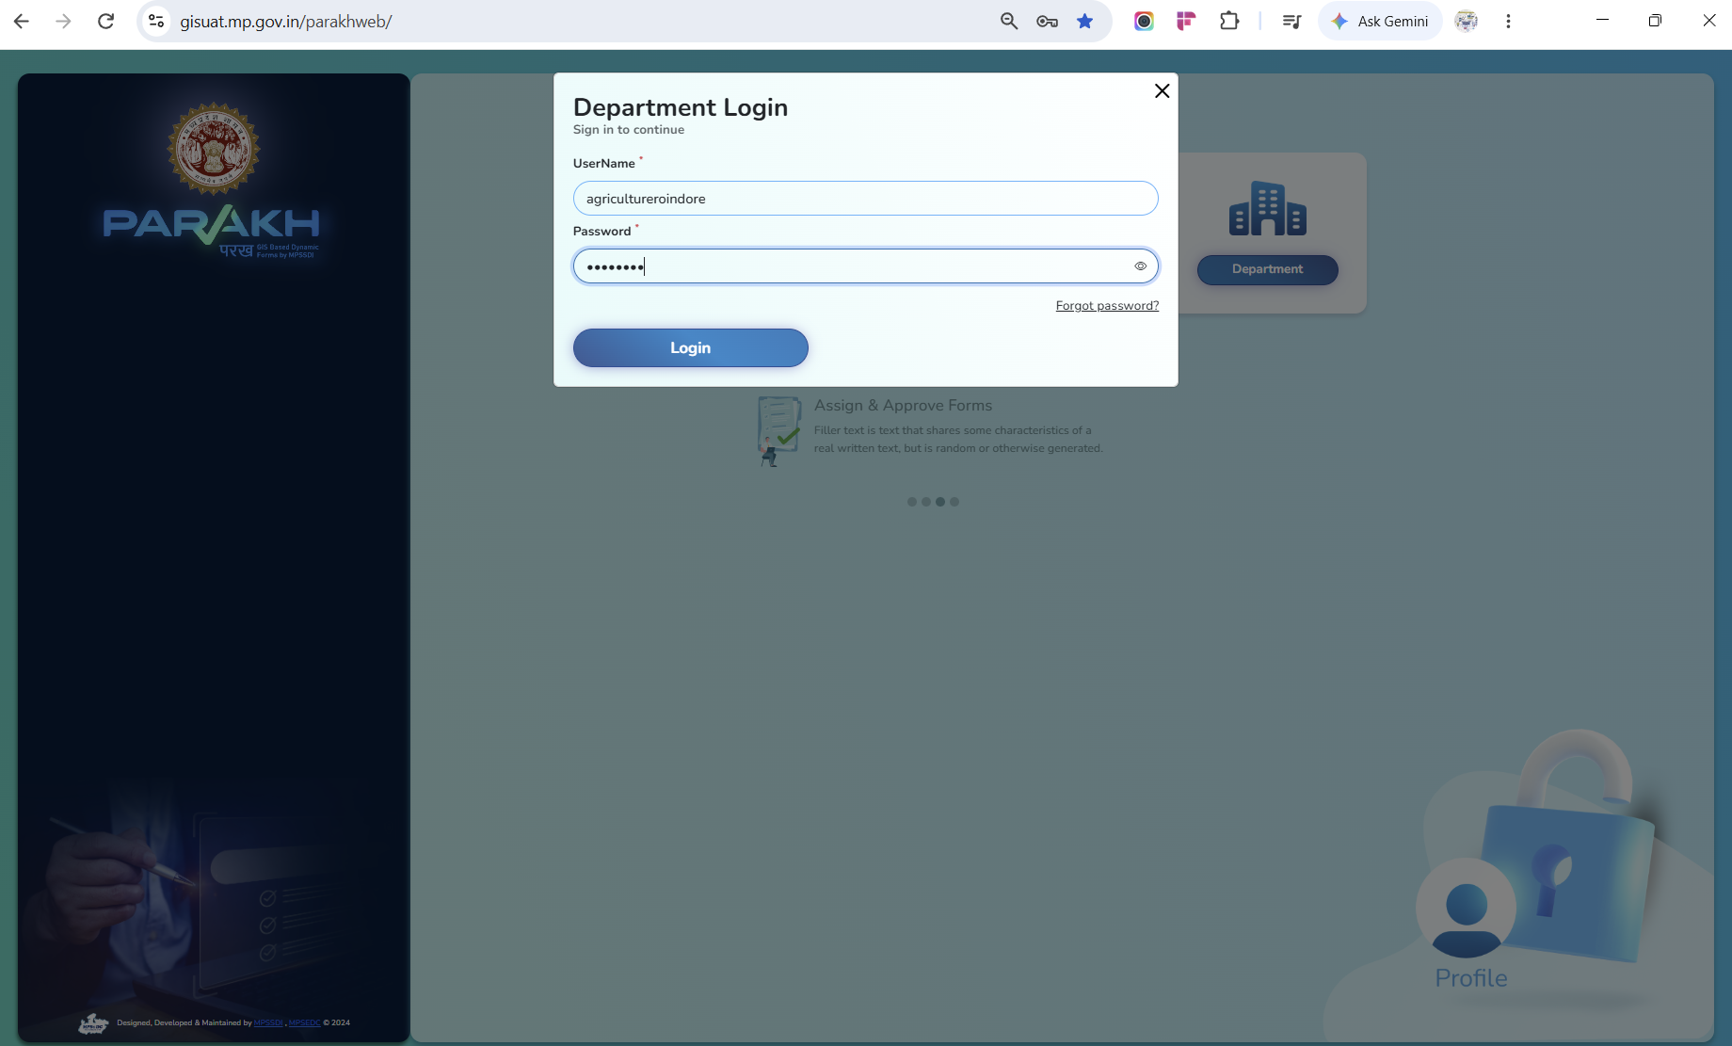
Screen 7 — Department Login as a Reporting Officer
WORK COMPLETED — COMPLETED: RO-scoped login confirmed working, correctly restricted to the RO's own department.

Step 8. Create an Inspector / Surveyor
ROLE ASSIGNED: Reporting Officer (Department HOD)
ACTIVITY PERFORMED:
- The RO opens Master → Create User to add the field-level Inspector/Surveyor who will conduct inspections under their department.
- Set User Type/Role to Inspector and Designation to Surveyor.
- The Reporting Officer field auto-fills to the creating RO (e.g. "agriculture RoP"), so every Inspector created here is automatically linked back to this RO.
- Select the Belongs to a Government Sub-Department (e.g. Krishi Vishwavidyalaya) and District/Block/Tehsil, then click Add User.
- A Bulk Upload Data option is also available on this screen for creating multiple Inspector records at once.
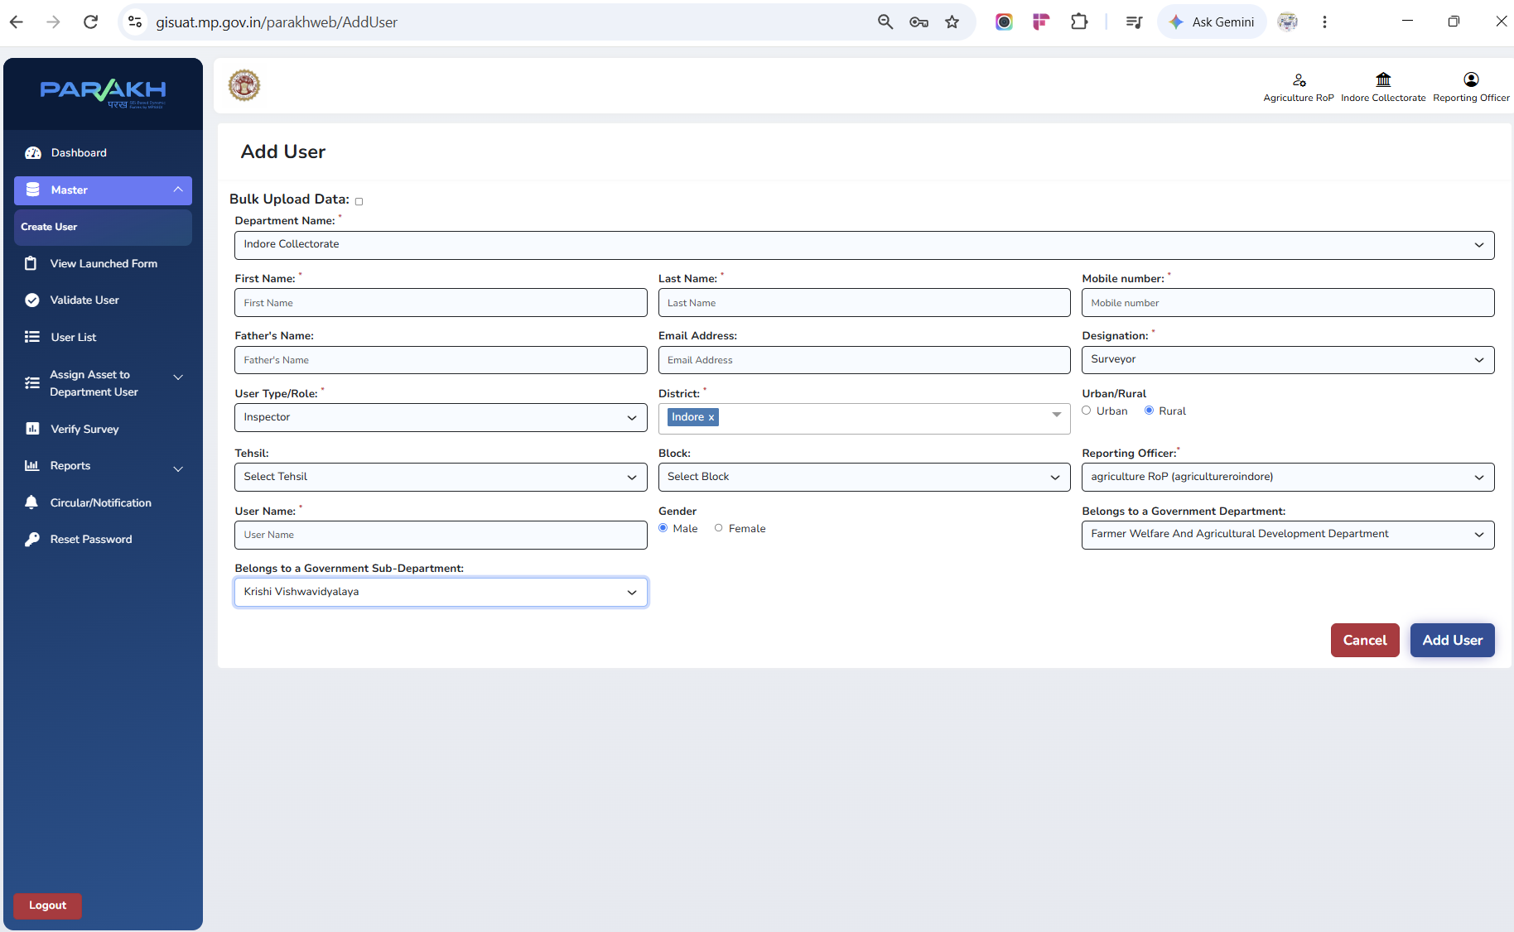
Screen 8 — Add User: Inspector/Surveyor created under the Agriculture RO
WORK COMPLETED — COMPLETED: Inspector creation, auto-linking to the creating RO, and Bulk Upload option all confirmed working.

Step 9. Preview the Department Inspection Form
ROLE ASSIGNED: Reporting Officer (Department HOD)
ACTIVITY PERFORMED:
- Before inspectors go into the field, the RO can open View Launched Form to preview the exact checklist that has been published for the department (here, the Agriculture Inspection Form).
- The preview shows every field the inspector will fill — Remark, Image upload, and the Yes/No checklist points (Seed stock, Fertilizer stock, Farmer services, Soil testing, Scheme implementation, Demo plots, Equipment, Field inspection, Records, and more).
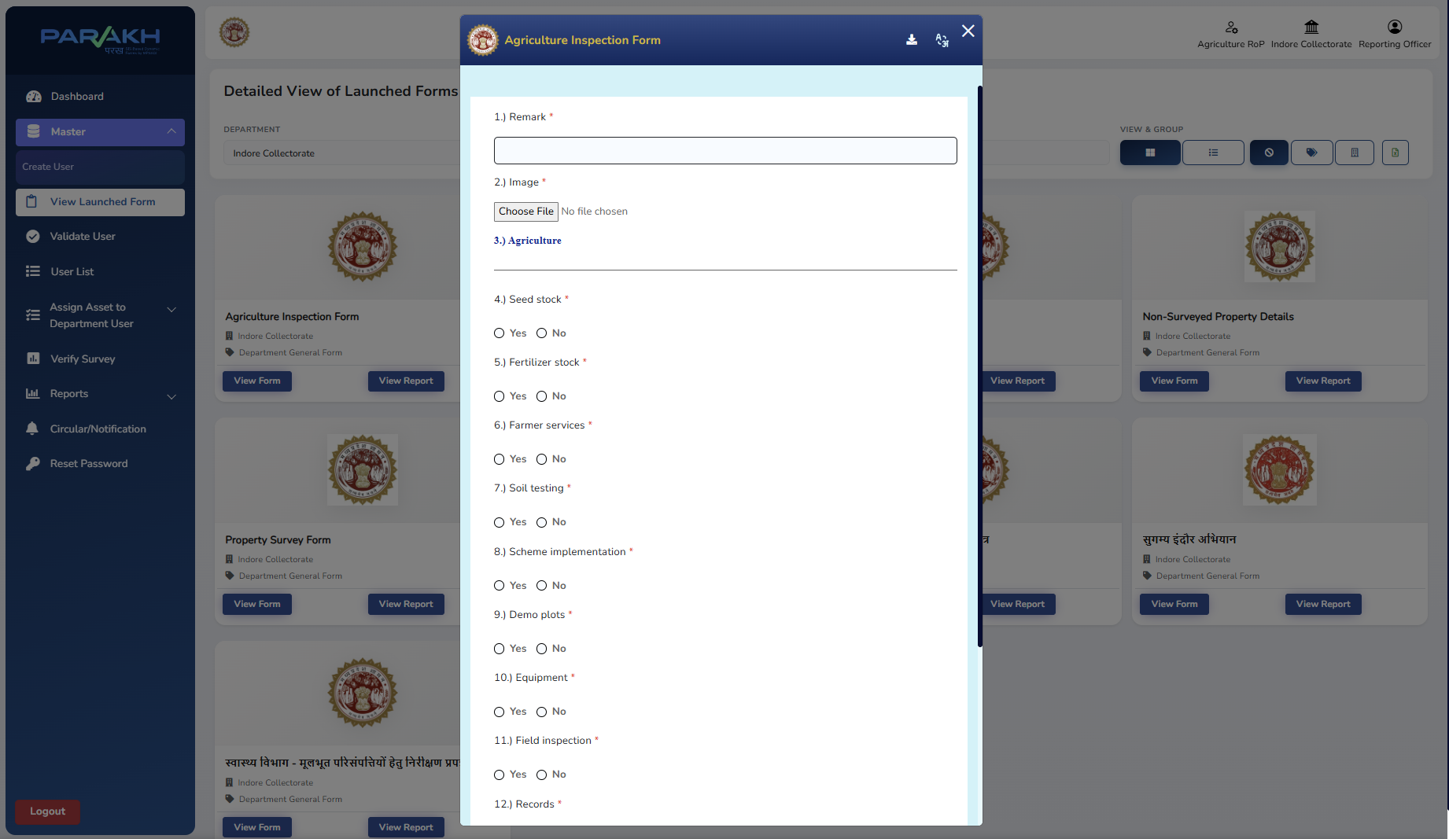
Screen 9 — View Launched Form: Agriculture Inspection Form preview
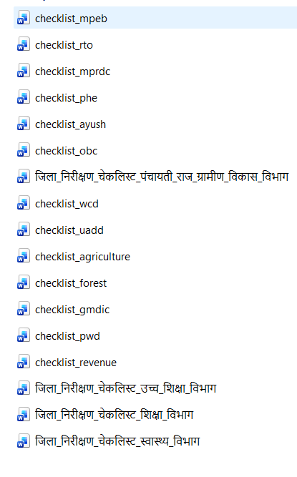
List of 17 Inspection forms needs to be prepared for Indore Inspection.
WORK COMPLETED — IN PROGRESS: Form preview working for launched forms. Of the 17 department checklists, a subset are launched at any given time — remaining department forms are being rolled out progressively.

Step 10. Verify the Inspector/Surveyor Record
ROLE ASSIGNED: Reporting Officer (Department HOD)
ACTIVITY PERFORMED:
- The RO checks User List, filtered to User Type/Role = Inspector and Designation = Surveyor, to confirm the record created in Step 8.
- Field note from this walkthrough: filtering by Department Name alone returned "No record found" — the Government Department filter (rather than Department Name) should be used to locate Inspectors mapped to a specific government department/sub-department.
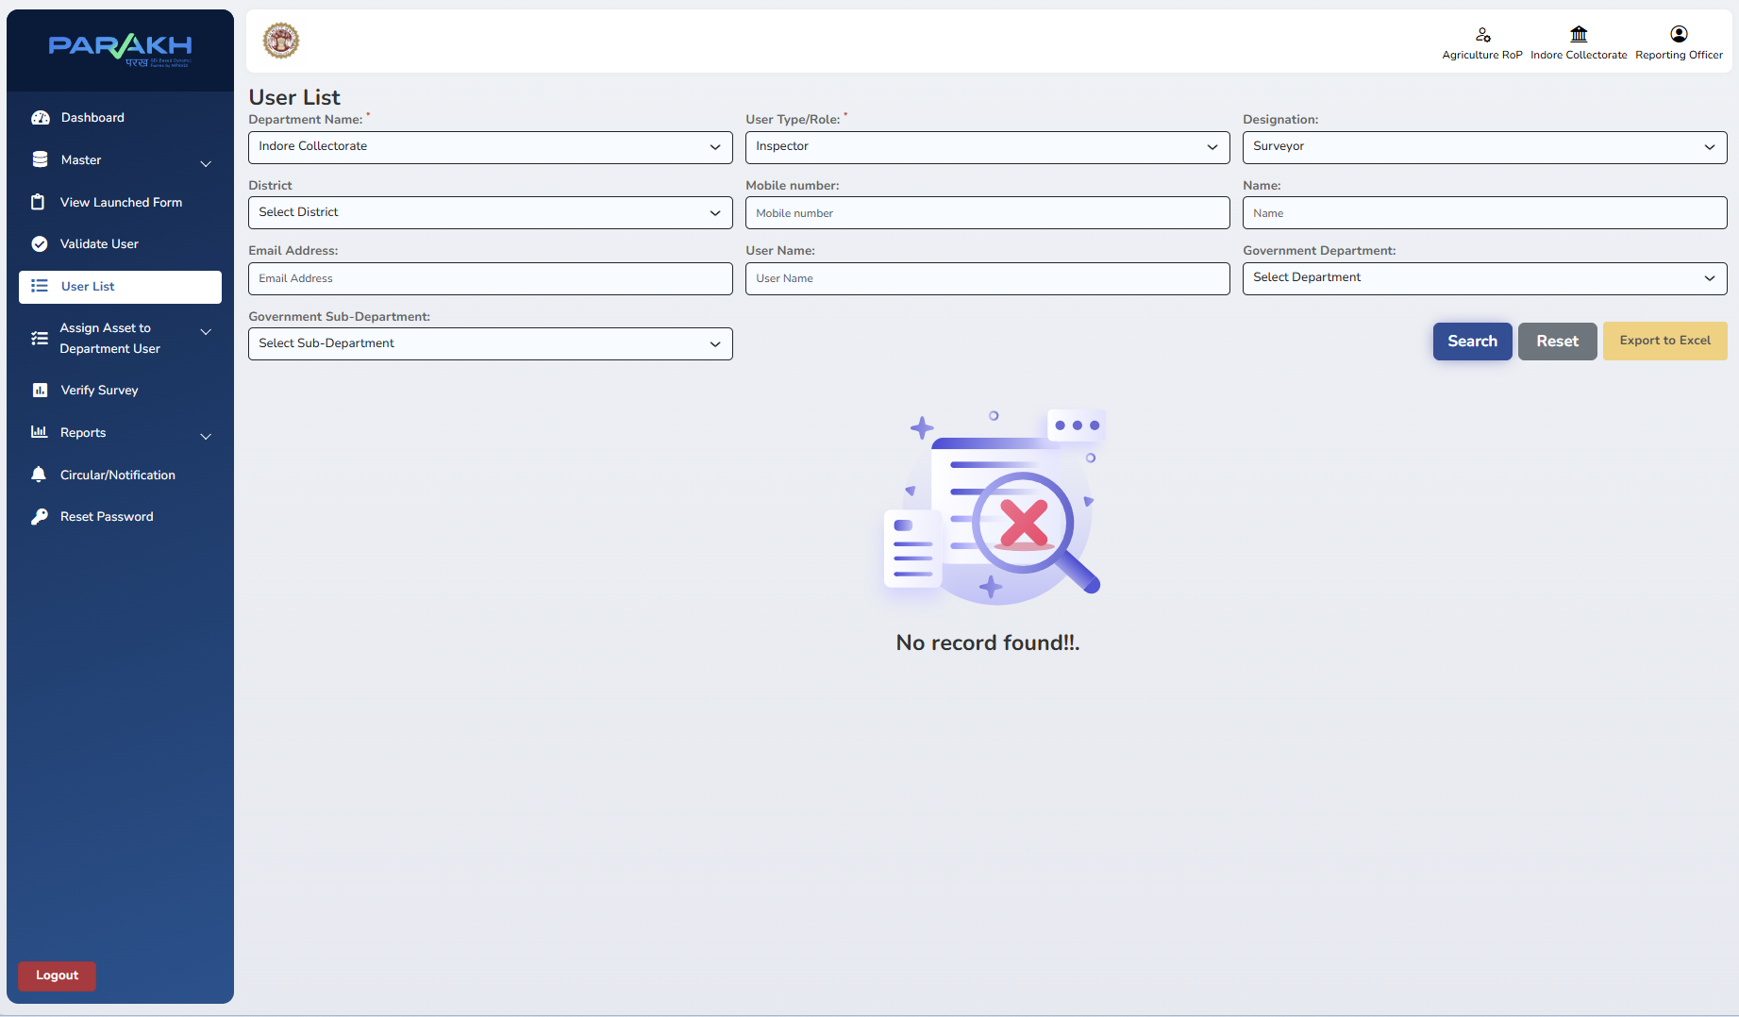
Screen 10 — User List filtered to Inspector/Surveyor
WORK COMPLETED - Filtering by Department Name in this walkthrough — the Government Department filter must be used and also select Sub-Department (child department of main department) corresponding to that specific department

Part C — Reviewing Inspections & Taking Action

Step 11. Open the General Form Report
ROLE ASSIGNED: State Admin / Reporting Officer
ACTIVITY PERFORMED:
- Navigate to Reports → General Form Report.
- The Form Name drop-down lists every inspection form currently launched. At the time of this walkthrough, nine forms were live, including four of the seventeen department checklists (Agriculture, Education, Health, Women & Child Development) plus five cross-cutting forms (Property Survey Form, Non-Surveyed Property Details, the two Sugamya Indore Abhiyan — divyang-accessibility — forms, and a generic Inspection Form).
- Select the required form to view its submitted inspections.
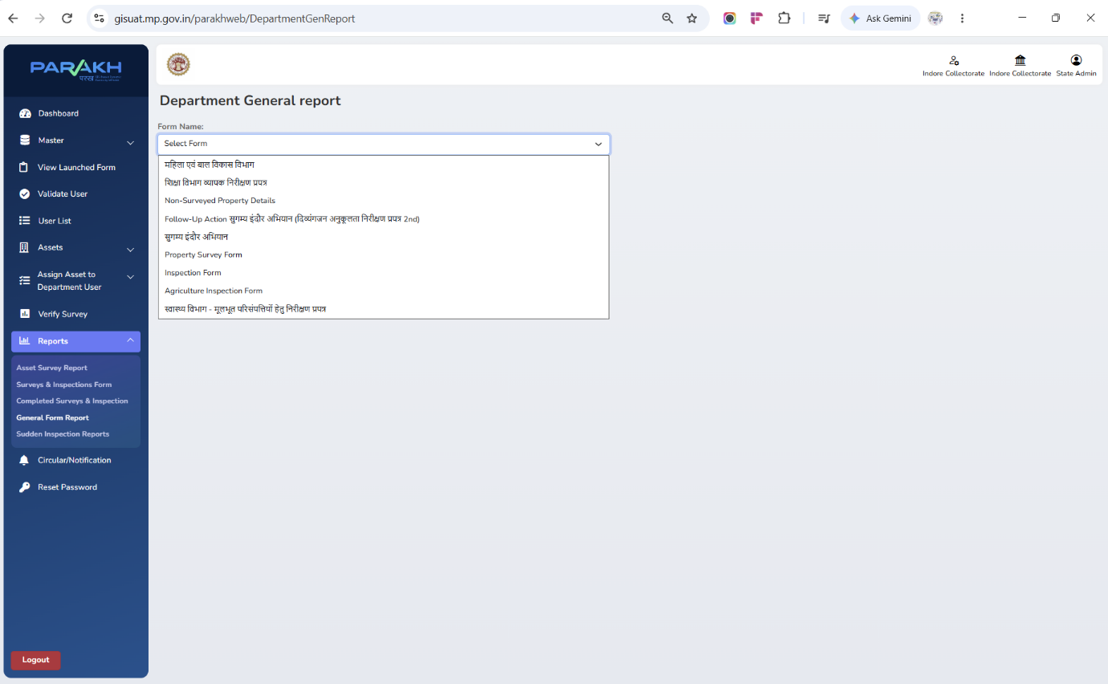
Screen 11 — Reports → General Form Report: Form Name drop-down
WORK COMPLETED — IN PROGRESS: Nine forms were live at the time of this walkthrough: 4 of the 17 department checklists (Agriculture, Education, Health, WCD) plus 5 cross-cutting forms (Property Survey, Non-Surveyed Property, the two Sugamya Indore Abhiyan forms, and a generic Inspection Form).

Step 12. Review Submitted Inspections
ROLE ASSIGNED: Reporting Officer (Department HOD)
ACTIVITY PERFORMED:
- Selecting a form opens a filterable, tile-summarised submission list with photos, map-view pin, and Status; RO clicks Action on any Submitted row.
- Selecting a form (here, शिक्षा विभाग व्यापक निरीक्षण प्रपत्र — the comprehensive Education Department form) opens a filterable, tile-summarised list of submissions (Total, Primary School, Secondary School, High School, etc.).
- Each row shows the checklist answers, both photos (View), the map-view location pin, and the current Status — Submitted for new entries, or Verified By Checker once actioned.
- The RO clicks Action against any Submitted row to review and act on it.

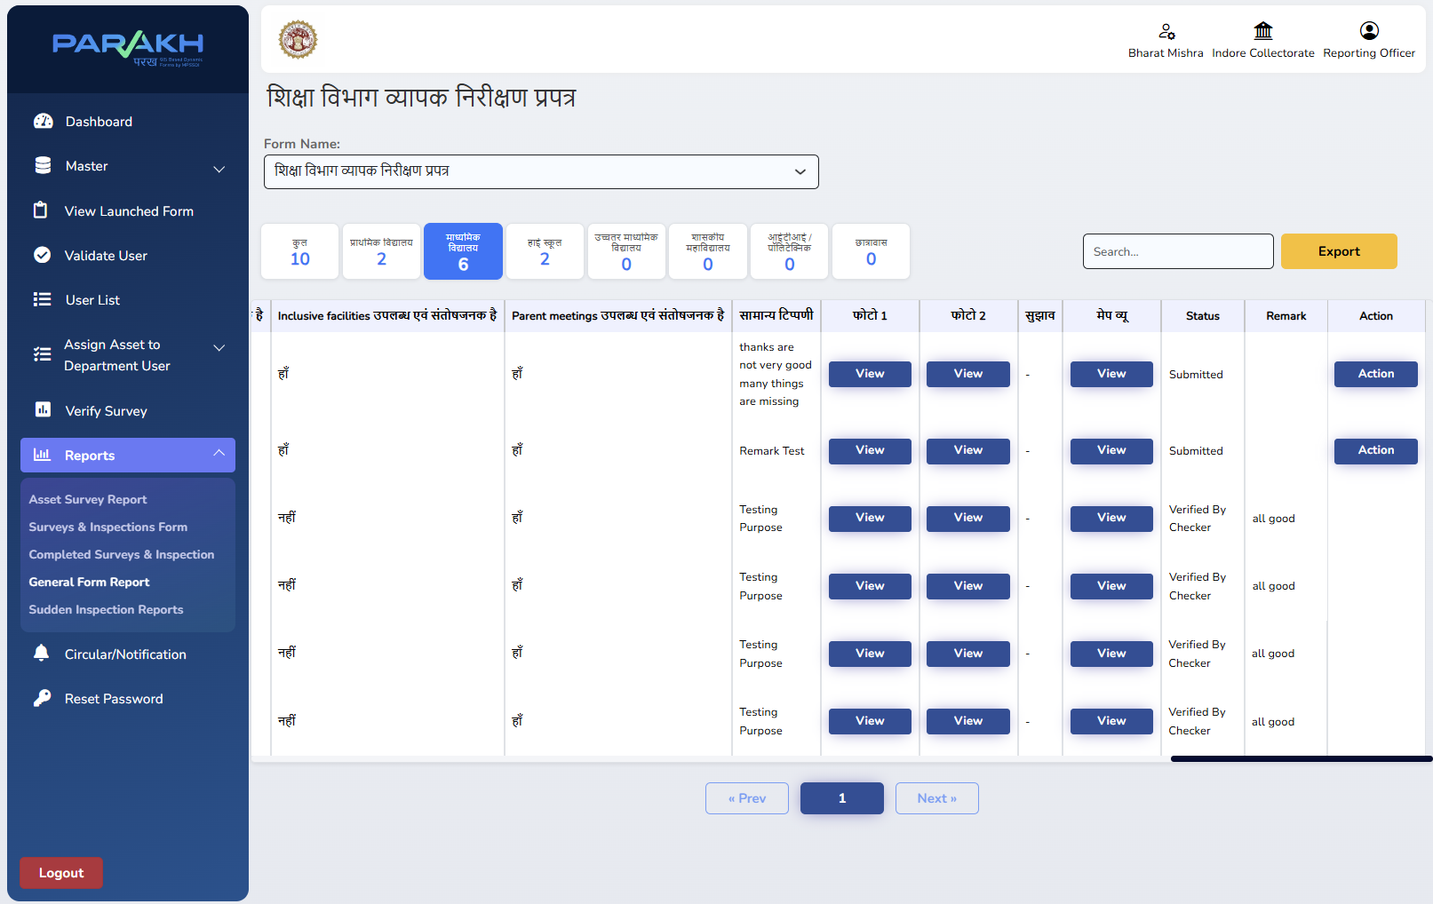
Screen 12 — General Form Report, Education Department, RO (HOD) view
WORK COMPLETED — COMPLETED: Submission list, photo/map view and Action trigger all confirmed working.

Step 13. Verify or Reject the Inspection
ROLE ASSIGNED: Reporting Officer (Department HOD)
ACTIVITY PERFORMED:
- The Verify Inspection pop-up opens with a mandatory Status field offering Verified By Checker or Reject, and a free-text remarks box.
- The RO selects the outcome, enters remarks, and clicks Submit — the record's Status and Remark update immediately in the General Form Report grid.
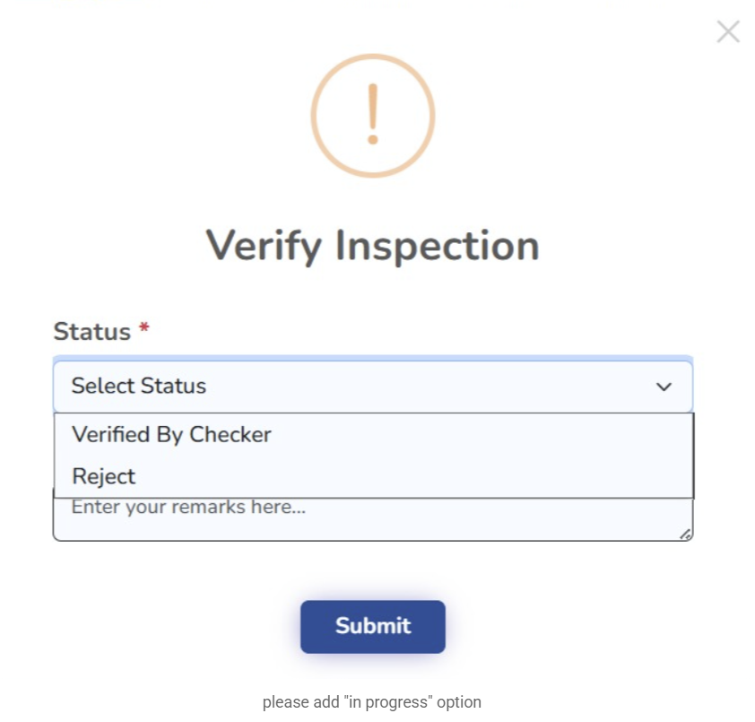
Screen 13 — Verify Inspection pop-up
WORK COMPLETED — COMPLETED PARTIAL: Verify/Reject with remarks confirmed working. An "In Progress" status option has been requested as an enhancement, in addition to Verified By Checker and Reject.

Step 14. Department-Wide Status Rolls Up to State Admin
ROLE ASSIGNED: State Admin
ACTIVITY PERFORMED:
- The same General Form Report, opened under the State Admin login, shows the same submissions across the department with an additional Accept status alongside Verified By Checker — reflecting a second, Collectorate-level confirmation on top of the RO's verification.
- This gives the State Admin a consolidated, department-wide view (here, School Education Department and General Administration/State Information Commission records together) without needing a separate login per department.
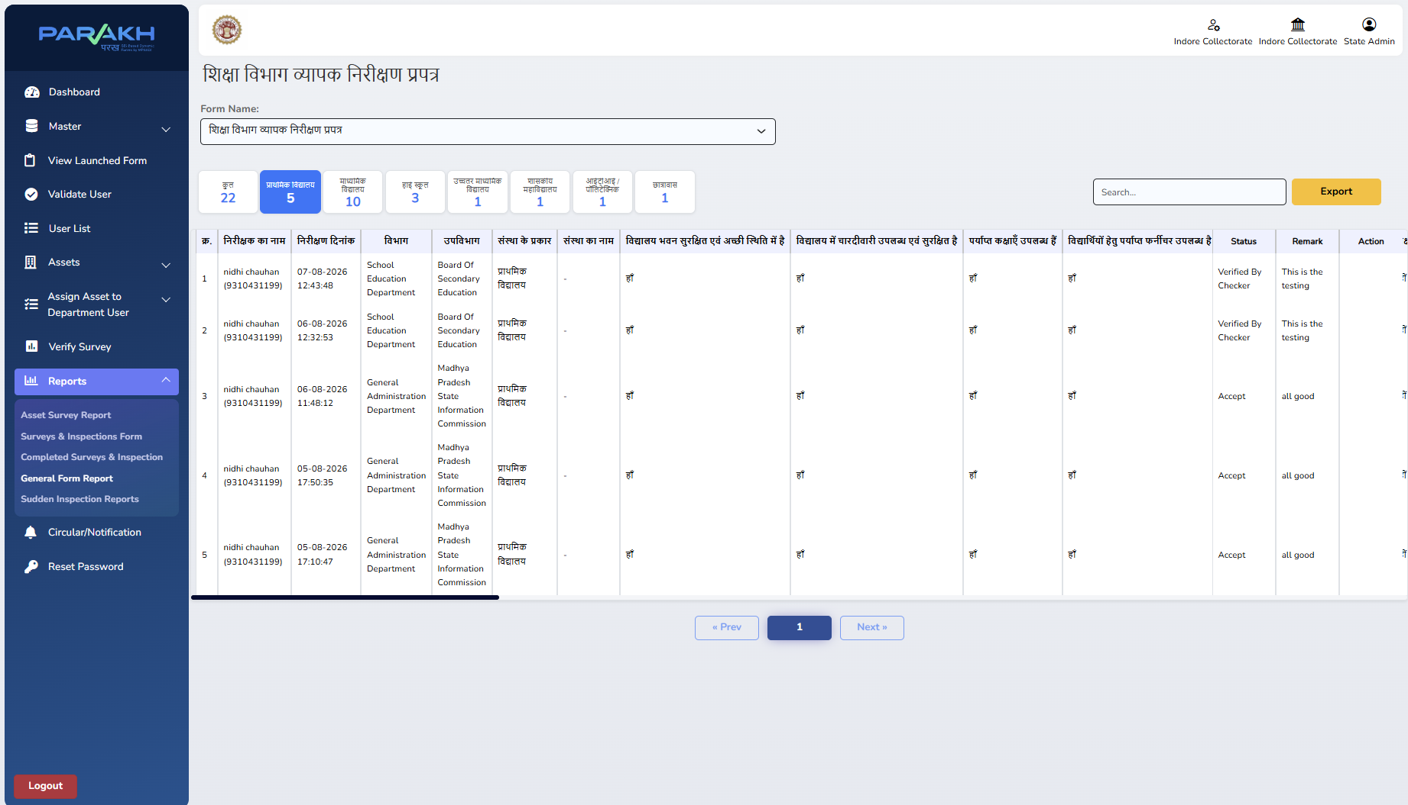
Screen 14 — General Form Report, State Admin view, showing Verified By Checker and Accept statuses

Part D — Nodal Officer: Collectorate-Level Monitoring

Step 15. Create the Nodal Officer (Collector's Representative)
Screen / URL: /parakhweb/Userlist
ROLE ASSIGNED: State Admin
ACTIVITY PERFORMED:
- The State Admin creates or verifies a Nodal Officer user — the login used to represent the Collector's office for monitoring purposes.
- In this walkthrough, "Shivam Verma" is registered as Nodal Officer under Indore Collectorate, reporting to indorecollectorateadmin, with username jc@123.
- The Activate/Deactivate toggle and Edit action are available against each user directly from this list.
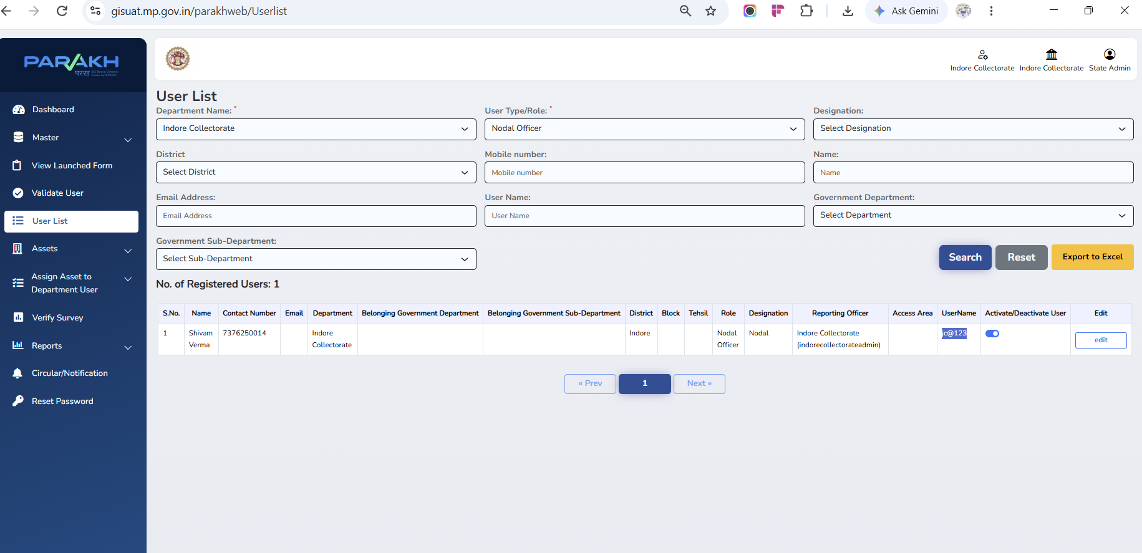
Screen 15 — User List filtered to Nodal Officer, showing the Collector's representative account

Step 16. Nodal Officer Monitoring View
ROLE ASSIGNED: Nodal Officer
ACTIVITY PERFORMED:
- Logging in as the Nodal Officer (shown top-right as "Shivam Verma … Nodal Officer") and opening the same Reports → General Form Report gives an identical, read-only view of every department's submissions and their Verified/Accepted status.
- This confirms that Collectorate-level monitoring does not require a separate reporting mechanism — it uses the same report, scoped to the Nodal Officer's login.

Phase 2 — Divisional Hierarchy
Madhya Pradesh is organised into 11 divisions at the state level. Phase 2 extends District GIS Parakh with a Divisional Officer login sitting above the Collectorate, giving division-wide visibility across every district under that division. For Indore Division, district-level login IDs were provisioned in the development environment for Indore, Khargone, Khandwa, Jhabua, Barwani, Dhar, Burhanpur and Alirajpur districts (e.g. gov_indore_division, gov_indore_district, gov_khargone_district, and so on).
Each divisional hierarchy will have their respective districts with their roles and credentials such as
Username id: gov_indore_division -- @ Indore Division
And respective districts and departments under that division as follows:-
Username id: gov_indore_district
Username id: gov_khargone_district
Username id: gov_khandwa_district
Username id: gov_jhabua_district
Username id: gov_barwani_district
Username id: gov_dhar_district
Username id: gov_burhanpur_district
Username id: gov_alirajpur_district

Above all users created for Indore division with it’s governed districts & their roles in development environment.

Step 17. Divisional Officer Login
Screen / URL: 172.18.200.177/parakhweb/ (development environment) · Username: gov_indore_division
ROLE ASSIGNED: Divisional Officer
ACTIVITY PERFORMED:
- Open the Department Login pop-up and sign in with the division-level username (gov_indore_division) and password.
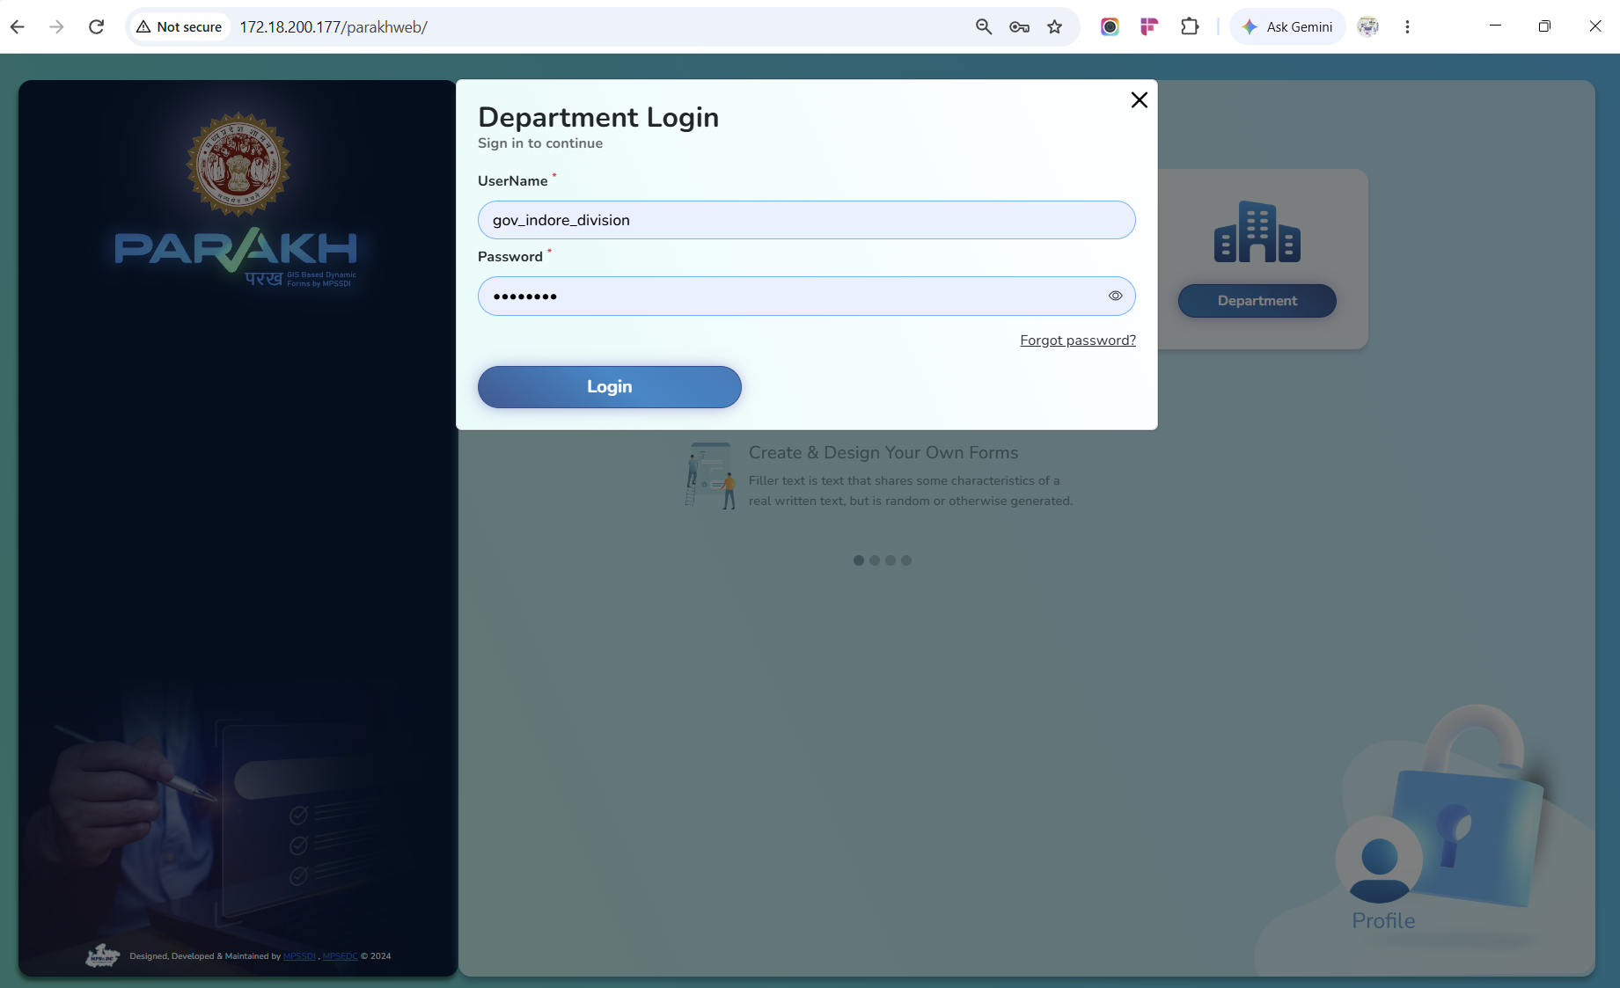
Screen 17 — Department Login as the Indore Divisional Officer
WORK COMPLETED — COMPLETED: Division-level login confirmed working in the development environment; division/district credentials for all 8 districts under Indore Division have been provisioned.

Step 18. Division-Wide Launched Forms & Department Visibility
ROLE ASSIGNED: Divisional Officer
ACTIVITY PERFORMED:
- View Launched Form opens with a Department drop-down spanning every district collectorate under the division (Indore, Dhar, Barwani, Burhanpur, Khargone, Jhabua, Khandwa, Alirajpur Collectorates) plus division-wide state departments (Health, Ayush, Public Instructions, Panchayat & Rural Development and its PNRD-MGNREGA/MPSRLM/PMPOSHAN sub-units, Tribal Affairs, Transport, MPRRDA, Swachh Bharat Mission, General Department).
- This confirms the Divisional Officer's view is not limited to Indore Collectorate alone, but rolls up every district and department in the division into one screen.
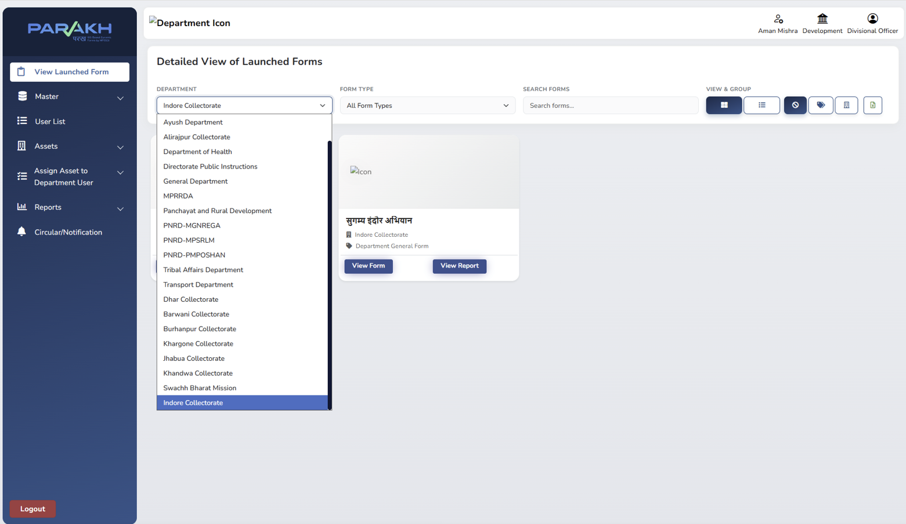
Screen 18 — View Launched Form: division-wide Department drop-down (8 districts + state departments)
WORK COMPLETED — COMPLETED: Division-wide department/district drop-down confirmed working and populated correctly.

Step 19. Create Users at Division Scope
ROLE ASSIGNED: Divisional Officer
ACTIVITY PERFORMED:
- Master → Create User at division scope allows the District field to become a multi-select (e.g. Barwani, Jhabua, Alirajpur, Khandwa, Burhanpur), so one Reporting Officer can be scoped to several districts at once if required.
- The Reporting Officer field can point to a District Collector directly — e.g. "IAS Shivam Verma (indore_collector)" is available as the reporting line for a new Transport Department user in this walkthrough. ( NOTE: In this Hierarchy collectorate officer such as IAS can be Nodal as well)
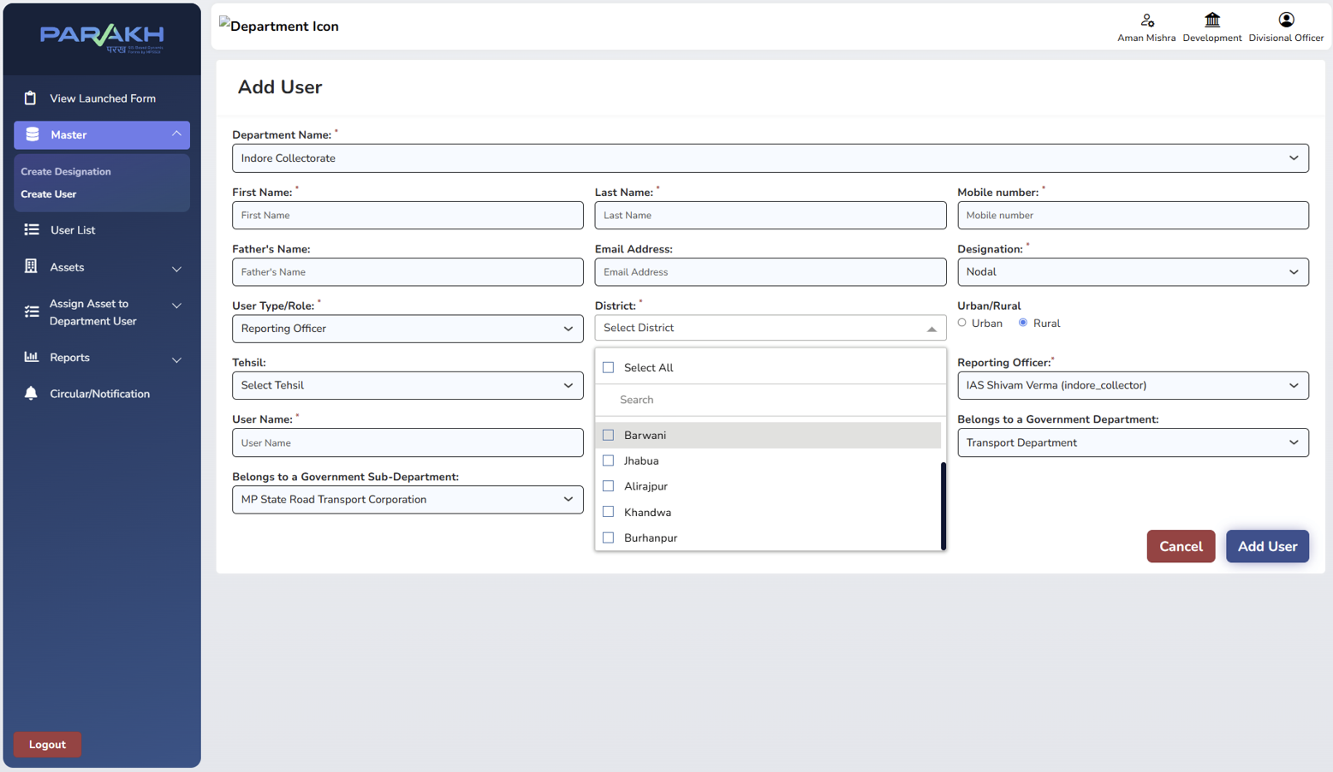
Screen 19 — Add User at division scope: multi-district selection and Collector as Reporting Officer
WORK COMPLETED — COMPLETED: Multi-district user creation and Collector-level reporting-line assignment confirmed working.

Step 20. Division-Wide User List
ROLE ASSIGNED: Divisional Officer
ACTIVITY PERFORMED:
- User List at division scope shows the same district/department drop-down as Step 15 & 18, and lists Reporting Officers created under the division with their Reporting Officer (Collector) linkage and UserName.
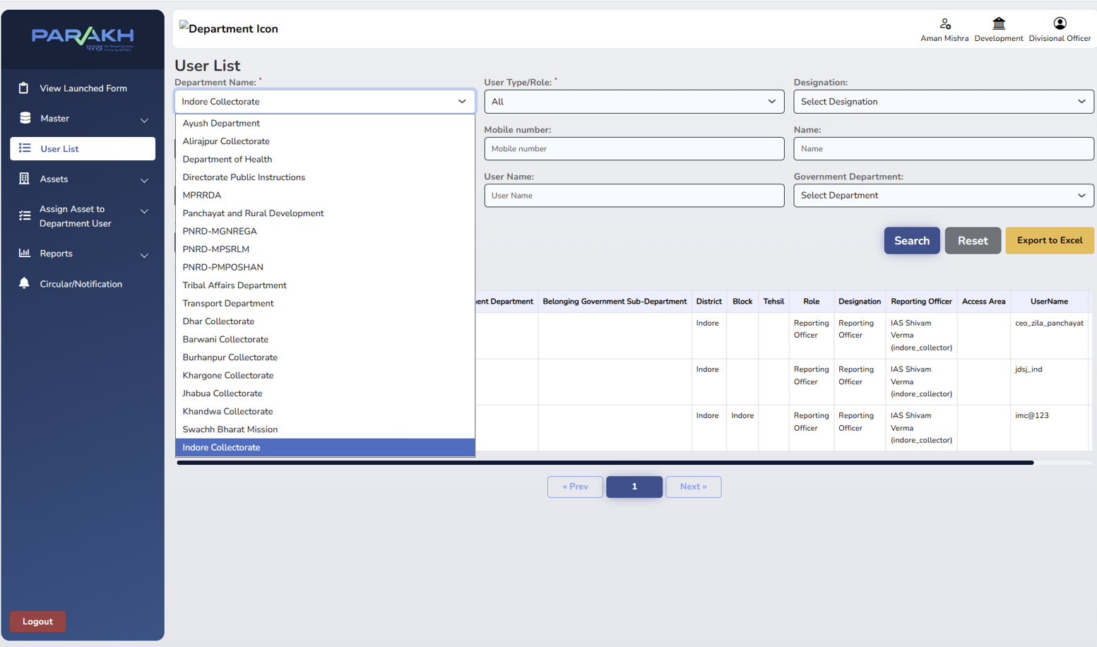
Screen 20 — User List at division scope
WORK COMPLETED — COMPLETED: Division-scoped user list confirmed working, correctly showing Collector-linked Reporting Officers.

Step 21. Asset List & Asset Assignment
ROLE ASSIGNED: Divisional Officer
ACTIVITY PERFORMED:
- Assets → Assets List, and Assign Asset to Department User (with Assign for Inspection & Survey / Assign for Data Collection sub-options), are available for allocating assets to users once asset master data is populated.
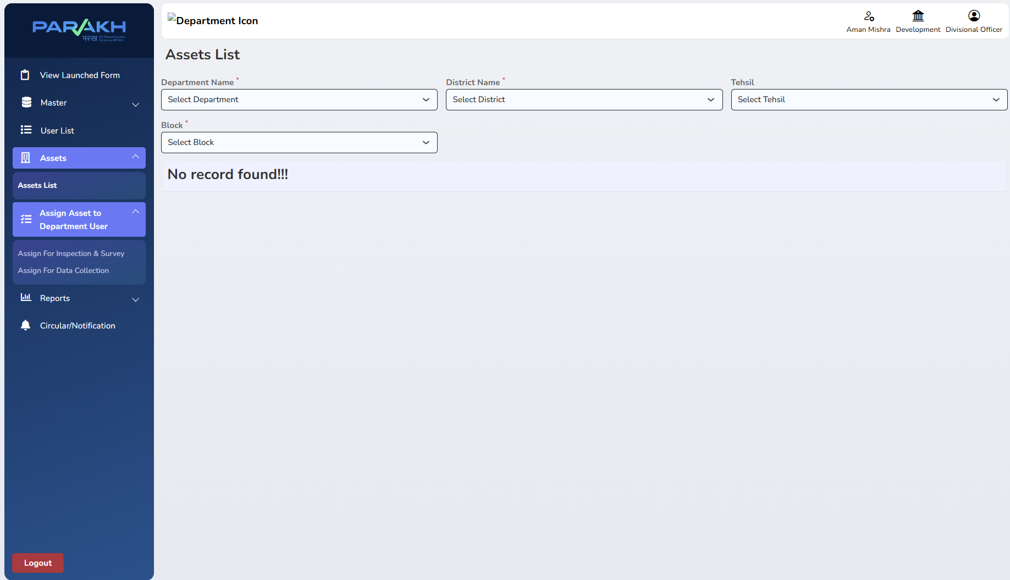
Screen 21 — Assets List and Assign Asset to Department User menu
Screen and menu structure are live, for the Department/District/Block combination tested — asset master data has not yet been populated for this scope. Logged as an open item, not a defect.

Step 22. Division-Level Department General Report
ROLE ASSIGNED: Divisional Officer
ACTIVITY PERFORMED:
- Reports → Reports: Department General Forms, filtered by Select Department and Form Name (e.g. सुगम्य इंदौर अभियान), returns the full inspection log — inspector name and mobile number, inspection date, designation, block, tehsil, nagar nikay, building type/category/name/address/photo — exportable to Excel.
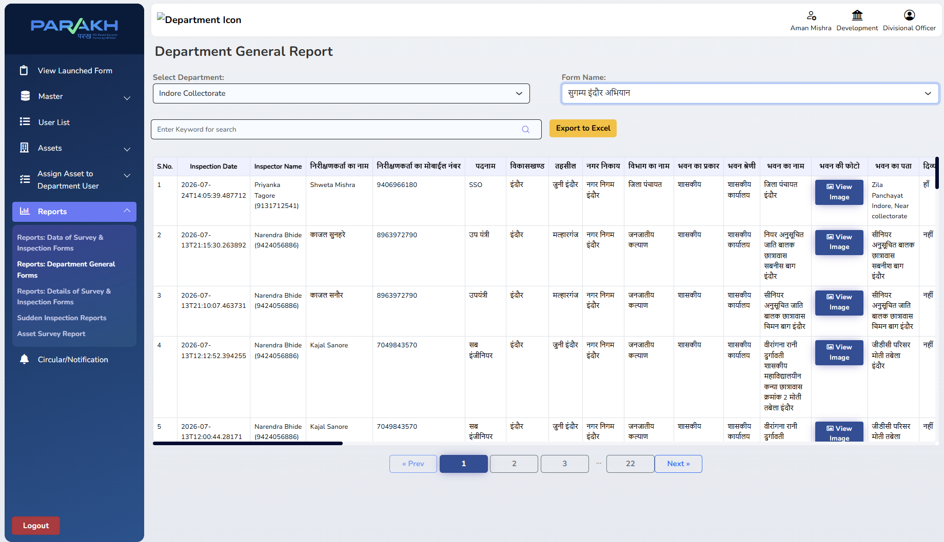
Screen 19 — Department General Report at division scope, showing live inspection records
WORK COMPLETED — COMPLETED: Confirmed data of inspection records were returned for a single form in this walkthrough, demonstrating the division-level report is functioning end-to-end on current data.

What's Next — Step 20: Mobile-Based Inspection

Step 23. Move Inspection Capture to the Mobile App
ROLE ASSIGNED: Inspector / Surveyor (field use)
ACTIVITY PERFORMED:
- Install the UAT build of the District GIS Parakh mobile APK (to be shared by the development team) to verify and validate that each department's inspection form behaves correctly against the requirement shared by that department.
- Once UAT validation is complete, uninstall the UAT build.
- Install the PROD build from the Google Play Store (Android) and use it as the live app for field inspections going forward.
WORK COMPLETED — GAP OBSERVED: Not yet started as a formal validation cycle — this is the planned next step following completion of the web-based Phase 1 and Phase 2 walkthroughs documented above.

Work Completed — Consolidated Summary
Status across both phases, as observed during this round of walkthroughs:
Capability | Phase | Status
State Admin setup, Reporting Officer creation & department mapping | 1 | Completed
Inspector/Surveyor creation under a Reporting Officer | 1 | Completed
Department-specific inspection forms (4 of 17 launched) | 1 | In Progress
Inspector/Surveyor filter by Department Name in User List | 1 | Gap Observed
General Form Report — review & Verify/Reject action workflow | 1 | Completed
"In Progress" status option on the Verify Inspection pop-up | 1 | Requested Enhancement
State Admin / Nodal Officer consolidated monitoring view | 1 | Completed
Divisional Officer login & division-wide department/district visibility | 2 | Completed
User creation at division scope (multi-district, Collector reporting line) | 2 | Completed
Division-wide User List, incl. Reporting Officer (Limited Access) role | 2 | Completed
Asset List & Asset Assignment at division scope | 2 | Gap Observed
Division-level Department General Report (live data) | 2 | Completed
Mobile app — UAT validation, then PROD rollout via Play Store | Next | Not Started

This manual will be updated as each additional department form is launched, as the Asset Assignment module is populated with master data, and as mobile-based inspection moves from UAT validation into production use.

